Autobiographical writing in contemporary French literature:
a dialogue between subject science and subject didactics

Author: Melanie Koch-Fröhlich, University of Freiburg

The present OER is situated at the interface of subject science and subject didactics. It is intended to show how the genre of autobiography can be examined from the perspective of two disciplines within a university course. The course is aimed at students of the Master of Education programme (upper secondary school) who are in the final phase of their studies. The course content relates to contemporary French literature, but can also be adopted to other (foreign) languages taught at school.

- Course design
Autobiographical narratives have been booming in France at the latest since the turn of the millennium. New texts are emerging that undermine clear genre classifications and move self-reflexively between autobiography, biography, social analysis, and fiction. The Integrated Master’s course presented in the following explores these aesthetic hybrid forms within the heterogeneous field of contemporary French literature. Situated at the interface of two disciplines, the course deals with the question which scientific concepts, narrative and rhetorical techniques can be of interest for didactical matters and to what extent these intersections might influence methods of teaching in the foreign-language classroom. In doing so, we are guided by the fact that subject didactics do not simply transfer scientific concepts into their own discipline-specific context, but for their part contribute to the field of subject science by transmitting their own theories and knowledge. Autobiographical narratives prove to be of value for both disciplines, and this applies in several respects:
a) Subject science and autobiography:
- Autobiography as a form of knowledge for historical, political and social matters
- Autobiography as a field of negotiation for theories on fiction
- Autobiography as textual materialisation of identity and memory
- Autobiography in its interrelation with (social) space
- Autobiography as an intermedial genre
b) Subject didactics and autobiography:
- Autobiography as useful approach for the development of reading and writing competence
- Autobiography as useful approach for the development of general media competence
- Autobiography as useful approach for the development of narrative competence
- Autobiography as useful approach for dealing with questions of identity and personality formation
- Autobiography in the foreign-language classroom: genre knowledge vs. creativity

A
U
T
O
B
I
O
G
R
A
p
H
Y

 Focusing coherence: choosing intersectional topics that are relevant to both subject-scientific and school-related interests – meaningfulness as a coherence factor

Our approach to autobiographical writing is twofold, by means of critical essays and particular literary texts. In terms of methodology and content, the course therefore consists of two blocks: a first block (i.e. seven weekly sessions) held on autobiographical theory and a second block (i.e. six weekly sessions) dedicated to contemporary autobiographical literature. During the theoretical phase, students examine selected essays on autobiography, both from the fields of subject science and subject didactics. After dealing with this theoretical background, we then draw connections between theory (subject science + subject didactics) and literature  (annex 1) as well as consider the potential implementation of the theoretical concepts in the foreign-language classroom. At the same time, the course introduces students to the major categories of contemporary autobiographies, i.e. autofiction, autosociobiography and “filiation stories” (récits de filiation, as defined by Dominque Viart). Under this designation, Viart groups together non-fictional texts dealing with questions of genealogy, family transmission and identity. As of the summer semester 2023, the participation in a public reading will complement the programme of the course.

According to the described approach, our text corpus (annex 2) consists of two different parts: On the one hand, students analyse theoretical texts on autobiography in the field of both disciplines (subject science and subject didactics). On the other hand, they explore autobiographical novels in excerpts. Each excerpt is accompanied by a brief introduction to the book and several interdisciplinary tasks (annex 3), on which the students work in self-study phases. The respective texts are then discussed in the weekly course sessions.
Focusing coherence: evaluation of the students’ submitted answers as a means of measuring achieved coherence (knowledge integration) by the lecturers: Are the didactic and school-oriented questions (also) answered with recourse to the results of the subject-specific analysis?

With regard to all three literary sub-genres (autofiction, autosociobiography, “filiation stories”) we try to select new texts every year whenever possible (for 2023, appropriate novels might be: Les presque soeurs by Cloé Korman, final round of the Prix Goncourt 2022; Beyrouth-sur-Seine by Sabyl Ghoussoub, Prix Goncourt des lycéens 2022; Ajar-Paris by Fanta Dramé; Comme nous existons by Kaoutar Harchi; Quand tu écouteras cette chanson by Lola Lafon). Additionally, we pay attention to the fact that the selected novels show thematic overlaps, such as the figure of the “class defector” (transfuge de classe) appearing in the works of Ernaux, Louis and Henni-Moulaï. The focus on recent texts helps us to add new literary sub-genres (such as the gender-oriented autobiography published by Ivan Jablonka) to the literary canons of both university and school. Another objective is to counter the prevailing opinion that the protagonists of autosociobiographies are predominantly male. However, an increasing number of young women (many of them having migration background) think and talk about what they experienced, such as in Comme nous existons (2021) by Kaoutar Harchi and Ajar-Paris (2022) by Fanta Dramé.

Auto(socio)biographies are per se hybrid, mixing elements from different genres. In addition to probing the concept of “genre” itself, our reading also focuses on socio-political history about France: the Second World War, the Algerian War of Independence, the Trente Glorieuses (thirty-year period of economic growth), immigration, gender identity and discrimination, as well as the French educational system. We are especially interested in discovering how literary texts construct and engage in socio-political discourse. Our teaching is based on the assumption that literature is not only closely linked with culture and history, but represents itself one of several manifestations of culture. The novel Un rêve, deux rives (“One dream, two shores”) serves us as an example (annex 4) to illustrate the literary, didactical and socio-political relevance of autobiographies.
focusing coherence: highlighting the relevance of the chosen topics for target cultures – meaningfulness as a coherence factor (for teacher students as well as for pupils)

Due to time constraints, concrete methodological questions on how to work with autobiography in the foreign-language classroom do not figure in the curriculum of the course. Nevertheless, you can find some worksheets to be used at school here (annex 5).

Annex 1: Autobiography as a common field of research for subject science and subject didactics

Literary and Cultural Studies | Subject didactics | Literature
1) Literature as theory of fiction  - Theories of fiction  contained in literature  - Relations between theory and literature | - Development of children’s fictional competence  - Forms and functions of fictionality  - theoretical and narrative strategies of self-constitution serving as a model for self-reflection  - Autobiography and its potential to enhance creative work in the foreign- language classroom | Jean-Luc Coatalem: La part du fils  In the epilogue that concludes the story, Coatalem explicitly addresses the question of genre. He considers his text similar to a novel since many scenes could only be reconstructed with the help of fiction. The author explicitly acknowledges to the reader the fictional character of his book, which was indispensable for its creation. Nevertheless, he emphasises the documentary value of a text based on careful research. According to the theoretical works of Dominique Viart, a “filiation story” strives to restore dignity to an individual fate that has remained largely anonymous. This is also Coatalem’s intention.
2) Autofiction  - the unreliable narrator  - Autobiography and theory of reception: autobiographical vs. fictional pact | - concepts of authorship in the foreign-language classroom  - selection and critical reviewing of context materials  - representations of authorship (in the field of tension between authenticity and performativity: interviews, blogs, websites, lectures…) | Frédéric Beigbeder: Un roman français  In his book, Beigbeder repeatedly revolves around the question of the reliability of subjective memories. Can I trust my memory? This is the narrator’s central question to himself. At the same time, he underlines the fact that his autofictional novel merely reflects his own, sometimes euphemistically and incompletely presented view of life. Through an extensive use of metaphors, the narrator tries to approach the essence of memory.
3) The trope of palimpsest in literature  - The trope of palimpsest as a hermeneutic tool for textual interpretations  - The trope of palimpsest used as a concept to reflect upon questions of identity, history and (social) space (e.g. in postcolonial literature)  - The trope of palimpsest seen in context with other cultural theories (and their relevance for autobiographical writing): Pierre Bourdieu: habitus, Chantal Jacquet: complexion, Marianne Hirsch: postmemory) | - Raising awareness for the relational, hybrid, fragmentary and multitextual form of autobiographies  - Autobiography seen as a symbolic construction of identity  - Development of narrative competence in telling stories about ourselves  - Self-perception as multilingual subject (Claire Kramsch): plural identities related to language(s); subjective dimension of language use | Nadia Henni-Moulaï: Un rêve, deux rives  In her novel, the narrator establishes numerous connections between her own destiny as the French-born daughter of parents of Algerian origin and that of her father. Such a juxtaposition conveys the idea of plurality and intertwined histories and therefore recalls the literary trope of the palimpsest, applied in postcolonial literature to reveal parallels and historical continuities between events with disparities in space, origin and chronology. Throughout the novel, the Hirak works as a link between the present and the past, making the daughter aware of the fact that she still feels its long-term effects on a daily basis.  Ivan Jablonka: Un garçon comme vous et moi  In intellectual proximity to the concept of “complexion” developed by Chantal Jacquet, Jablonka outlines in his book a concept of identity that is in a state of constant change and therefore under constant reconstruction. With regard to the category of gender, Jablonka concludes that it is essential for the personal development of each of us to accept the discrepancy between the socially determined gender role and the individual reality of life, and to transform this inconsistency into something positive for one’s own self-image.
4) Ekphrasis  - Verbalisation of visual images: Literary description of photographs as a form of intermediality  - The ekphrasis as a means of description of identity concepts | Multimodal character of different forms of self-representations expressed in the foreign language;  interplay of verbal language and other forms of artistic self-staging (e.g. theatre, pantomime, photographs) | Annie Ernaux: Mémoire de fille  Ernaux regards photographs as a medium of self-knowledge. In her autobiographical work, she uses photographs from her childhood to reflect on the complexity of human identity. She understands identity as the sum of a multitude of identities we once lived through. Although photographs represent ourselves, there is an irreconcilable gap between the former and the present self. At the same time, the collective and social environment of a certain period (in the case of Ernaux the 1950s and 1960s) is inscribed in every portrait.
5) The Incipit: beginnings in autobiographical literature  - interaction between incipits and the story they introduce  - functions of the incipit; the incipit as a space of aesthetic condensation  - the role of epigraphs (serving as a preface to the novel)  - narratological and generic specifics of  incipits | The incipit in the foreign-language classroom:  - motivational aspect (incipit as a “space of seduction”)  - receptive and productive methods in working with incipits | Édouard Louis: Changer: méthode  The incipit of Louis’ book provides a framework which can be considered as typical for the genre of autobiography (how, when and why is one’s life story told?) and in a way justifies the autobiographical project undertaken. It is also striking that all the difficulties the narrator faces in writing his story already come up on the first page of the novel: Does autobiographical writing has a therapeutic effect or, on the contrary, does it aggravate the burden of the past that lies on our shoulders?

(back to top )
Annex 2: Text corpus

 Theoretical texts on autobiography (subject science):
1. Bourdieu, Pierre (1986): “L’illusion biographique”, in: Actes de la recherche en sciences sociales 62/63, 69-72.
2. Spoerhase, Carlos (2017): “Politik der Form. Autosoziobiografie als Gesellschaftsanalyse”, in: Merkur 71/818, 27-37.
3. Viart, Dominique (²2008): “Récits de filiation”, in: La littérature française au présent: héritage, modernité, mutations. Paris: Bordas, 79-96.
4. Wagner-Egelhaaf, Martina (2017): “Autobiographie als literaturwissenschaftliches Problem”, in: Depkat, Volker/Pyta, Wolfram (Hrsg.): Autobiographie zwischen Text und Quelle. Geschichts- und Literaturwissenschaft im Gespräch I, 43-56.

Theoretical texts on autobiography (subject didactics):
1. Aulf, Annika (2015): “Autofiktionale Texte als Anlässe von Selbstreflexion und Persönlichkeitsbildung”, in: Küster, Lutz/Lütge, Christiane/Wieland, Katharina (Hrsg.): Literarisch-ästhetisches Lernen im Fremdsprachenunterricht: Theorie – Empirie – Unterrichtsperspektiven (= Kolloquium Fremdsprachenunterricht 52). Frankfurt am Main: Lang, 179-191.
2. Hallet, Wolfgang (2015): “Autobiographies. Selbst-Erzählung und Selbst-Darstellung in der Fremdsprache”, in: Der fremdsprachliche Unterricht Englisch 136, 2-7.
3. McVeigh, Jane (2018): “Teaching Life as Story”, in: The European Journal of Life Writing VII, 15-28.

Literary texts:
1. Beigbeder, Frédéric (2009): Un roman français. Paris: Grasset. ⇨ autofiction
2. Coatalem, Jean-Luc (2019): La part du fils. Paris: Stock. ⇨ récit de filiation (“filiation story”)
3. Henni-Moulaï, Nadia (2021): Un reve, deux rives. Genève: Slatkine. ⇨ récit de filiation
4. Ernaux, Annie (2016): Mémoire de fille. Paris: Gallimard ⇨ autosociobiography
5. Édouard Louis (2021): Changer: méthode. Paris: Seuil. ⇨ autosociobiography
6. Ivan Jablonka (2021): Un garçon comme vous et moi. Paris: Seuil. ⇨ autosociobiography

(back to top )

Annex 3: Seminar activities

- Frédéric Beigbeder: Un roman français (“A French novel”)

Working on the text:

- Chapter 3:
- Which literary techniques does the narrator use to outline the difficulties of autobiographical memory work? What effect is achieved with the techniques used?
- What does the end of the paragraph say about the relationship between fiction and reality?
- Summarise the challenges that the narrator associates with the process of writing an autobiography? How can these statements be transferred to a hypothetical writing activity in the foreign-language classroom? Which opportunities and difficulties do you see here?

- Chapter 10:
- “My life is a police mystery where the balm of memory embellishes and distorts each piece of evidence.” What consequences does this metaphorical statement have both for the writing of the autobiography and for the “autobiographical pact” (Philippe Lejeune) between author and reader?
- The narrator understands the expression “family life” as an oxymoron. Give reasons for this assumption.
- What pedagogically relevant messages does this quotation contain? Where possible, make references to the educational plan for teaching French in upper secondary school (Bildungsplan, federal state of Baden-Württemberg).

- Chapter 19:
- “France being an amnesiac nation, my lack of memory is the irrefutable proof of my nationality.” What kind of connection does the narrator draw between collective and individual memory and why does he do so? Why is France assumed to suffer from collective amnesia?
- Make a brief linguistic analysis of the passage (vocabulary, grammar, syntax, rhetorical figures) and justify whether you think it is suitable for working with in the foreign-language classroom.

- Nadia Henni-Moulaï: Un rêve, deux rives (“One dream, two shores”)

Working on the text:

- p. 17-20
- What metaphors does the narrator use to describe her conflictual relationship with Algeria?
- According to Dominique Viart, “filiation stories” (récits de filiation) are characterised by a specific time structure that evokes the palimpsest metaphor. To what extent do you consider this time model realised in “One dream, two shores”?

- p. 89-93
- “The wounds of the present are so prominent that I seem to have forgotten their origins.” (p. 91). “I don’t know it yet, but the Algerian war remains a gap in the French unconscious” (p. 92). Which postcolonial image of French society do these statements evoke?
- Which self-image does the narrator draw of herself and in what way does it interact with society? Which connections can be drawn from these statements to Jacquet’s central concepts of “transclasse” (“class defector”) and “complexion”?
- Give reasons why the passage could be used to implement the principle of “tolerance and acceptance of diversity” (cf. educational plan for teaching French in upper secondary school) in the foreign-language classroom?

- p. 141-145
- In her research on the transgenerational transmission of memories (”postmemory”), Marianne Hirsch emphasises that the per se fragmentary character of photographs encourages the viewer to interpret them from the perspective of one’s own life: “Invariably, archival photographic images appear in postmemorial texts in altered form: they are cropped, enlarged, projected onto other images; they are reframed and de- or re-contextualized; they are embedded in new narratives, new texts; they are surrounded by new frames” (Hirsch 2012: 68). To what extent does this observation also apply to the scene described in this excerpt?
- According to Annika Aulf, autobiographical texts serve particularly well as a “model for reflection”. Show to what extent this assertion is applicable to the passage.

(back to top )
Annex 4: Text example
Nadia Henni-Moulaï (2021): Un rêve, deux rives (“One dream, two shores”)

In this (auto-)biographical text, Henni-Moulaï, born in 1983, investigates the story of her father, who emigrated to France in 1948 when Algeria was still a colony. By doing so, she returns to the intense ambivalence about her place in French society. Having grown up in a Parisian working-class suburb, she managed her successful career as a student at Sorbonne University only with considerable efforts. During the Hirak, the peaceful Algerian protest movements in 2019, she views her father’s fate in a different light.

- Relevance of the novel from the perspective of literary studies:
Despite its far-reaching historical significance, the Algerian War is still a blind spot for students of French. Since the 1980s at the latest, literature has played a decisive role in breaking the taboos surrounding the events of that time. This literary interest in the Algerian War remains relevant to this day. In 2017, three novels about the Algerian War (L’art de perdre by Alice Zeniter, Un loup pour l’homme by Brigitte Giraud, Nos richesses by Kaouther Adimi) were among the nominations for the Prix Goncourt, the most prestigious French literary prize. This trend has gained further momentum with the 60th anniversary of the Evian Agreement on 18 March 2022. In 2022 alone, numerous novels, some of them autobiographically inspired, were published on the topic of the Algerian war (including Au vent mauvais by Kaouther Adimi and Les Méditerranéenes by Emmanuel Ruben).

- Relevance of the novel from the perspective of subject didactics:
Reflecting the Algerian war raises many questions that are also of interest for didactical discussions: What responsibility does school bear as a place of learning to improve education on a subject that has been a taboo for decades in society and politics? What forms of representation of history can help pupils develop a critical political consciousness? What possibilities does contemporary francophone (youth) literature offer for approaching this topic? To what extent does literature demonstrate reading, learning and cognitive processes that can also be initiated in the foreign-language classroom (e.g. in the context of production-oriented teaching units)? Since the turn of the millennium, there has been an increasing treatment of the Algerian war in children’s and youth literature, e.g. Histoire dessinée de la guerre d’Algérie (2016) by Benjamin Stora and Sébastien Vassant as well as Toutes les couleurs de mon drapeau (2018) by Mabrouck Rachedi.

- Current socio-political relevance of the novel:
In early 2021, Benjamin Stora, a respected French historian of Algerian origin, delivered a government-commissioned report in order to encourage the Franco-Algerian reconciliation. The report offers concrete proposals to establish a dialogue between different memorial groups and thus to promote social cohesion. It can be fruitfully used to discuss the memorial significance of some of these proposals with university students (or in the foreign-language classroom).

(back to top )

Annexe 5: Activities in the foreign-language classroom
Author: Jakob Willis (University of Education, Freiburg)
What is autobiography?
To write an autobiography is to become the author of one’s own life (...).
Dominique Viart
(professor of literature)
Definition of autobiography:
A retrospective account in prose that a real person makes of his own existence stressing his individual life and especially the history of his personality.
Philippe Lejeune
(professor of literature)
I am not building a fictional character. I am deconstructing the girl I once was.

Annie Ernaux (writer)
In every imaginary work, there is a self-narrative. In every autobiography, there is an imaginary reworking.

Boris Cyrulnik (psychiatrist)

How do we portray ourselves “accurately”? How do we show ourselves "as we are"? It is not easy to say true things about ourselves.

Ivan Jablonka
(historian and writer)
Every autobiography (...) is a self-interpretation.
Jean Starobinski
(professor of literature)
That's why I love autobiography: it seems to me that there is an adventure buried within us that is just waiting to be discovered (…).

Frédéric Beigbeder (writer)
Writing an autobiographical text
First steps

Nothing easier than writing an autobiographical text? Certainly not...
→ The following aspects can help you to find one or more topics to talk about an important experience you had in the past. This may serve as a starting point to write the chapter called "Yesterday".

- Think about what happened and how you experienced it personally.
- Think about the impact of the experience and how you think about it now.
- Show yourself as you are but also think about protecting your privacy.
- Write your text in the first person.
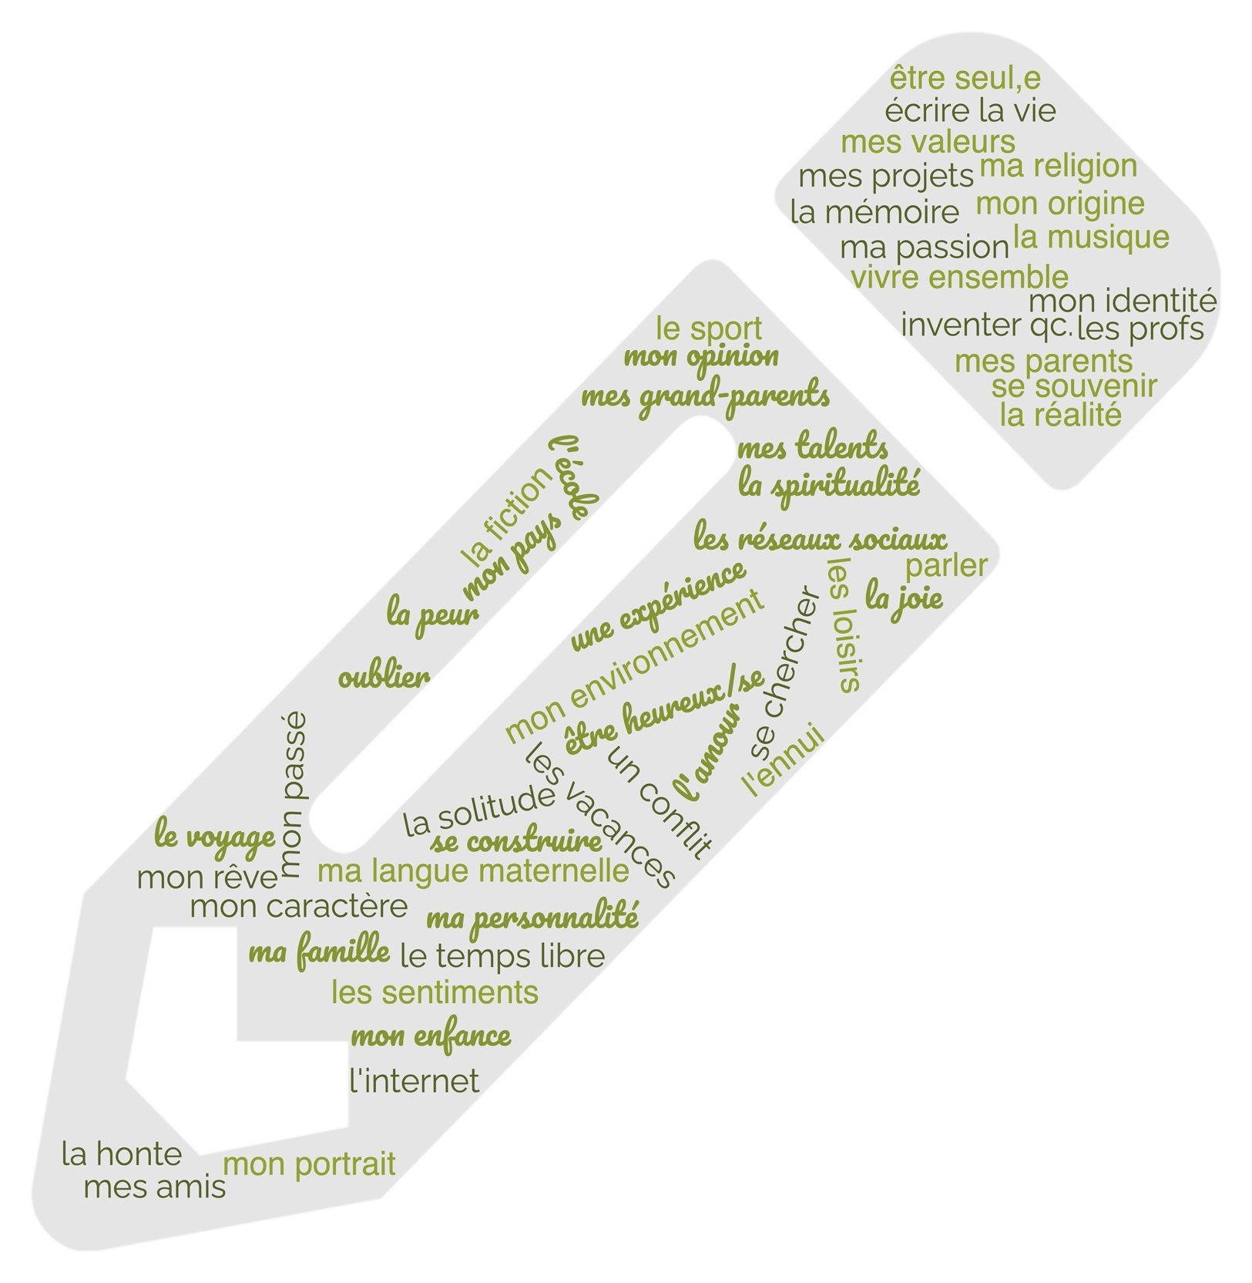
(back to top )

