Subject sciences and subject didaktics in dialogue: A task-based tandem seminar
Frank Reiser (University of Freiburg), Katja Zaki (University of Education Freiburg)

I. General information about the seminar
The seminar is part of an integrated module at the end of the Master's programme and aims at enabling the students to…
… explore an exemplary school-relevant topic from a subject-specific and subject-didactic perspective,
… reactivate relevant subject-specific and subject-didactic contents from previous study phases,
… relate and integrate the findings from the various disciplines in a meaningful way
… use and transform these findings independently in a productive way with regard to a treatment of the topic in ‘real life’ Spanish lessons at secondary level.

The chosen exemplary subject is cultural memory in Spanish literary texts.
Topic-specific intended learning outcomes:
The students ...
... are familiar with core theories in cultural memory studies,
... understand dimensions and functions of media of remembrance and can apply theoretical approaches to Spanish/Hispanic-American media cultures,
... can understand/analyse literature and other cultural texts as an element of the cultural imaginary and cultural memory and take into account transcultural discourses,
... can relate their knowledge of cultural/literary studies and subject didactics on memory cultures to their [future] work as a foreign language teacher,
... know the basic paradigms and principles of neo-communicative Spanish teaching and can justify didactic and methodological decisions in their own teaching concepts – including cross-phase perspectives,
... can analyse authentic texts and other cultural media in terms of language, culture and media didactics and implement them in a competence/task-oriented way,
... have the capacity to plan and reflect foreign language teaching and learning processes (taking into account content-related and procedural competence goals of the subject as well as interdisciplinary aspects).

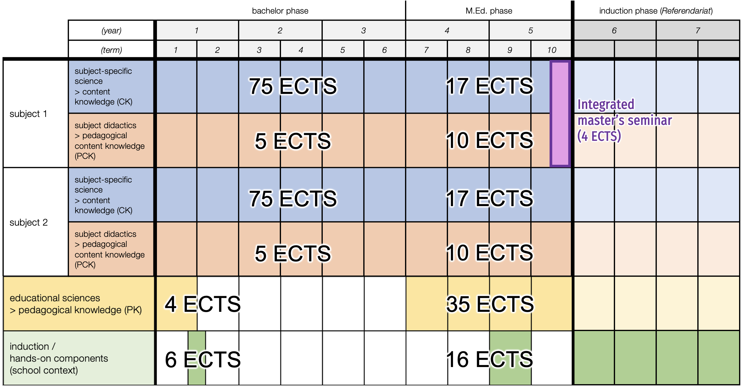
II. Curricular context

The teacher training system in Germany is a consecutive dual system, consisting of university studies (5 years) and induction phase (Vorbereitungsdienst or Referendariat, 1.5-2 years), and always includes at least two subjects.
In Freiburg, the university study phase is again implemented in two stages, with a predominantly subject-oriented polyvalent Bachelor’s degree and a strongly pedagogically focussed Master of Education (see diagram).
The seminar is located in the final phase of the M.Ed. curriculum.
III. Overall structure and design principles

Brief outline of the TE and curricular context and synopsis of the course concept in a short explanatory video here. Two key principles form the foundation on which the course is based: (1) the task-oriented 4C/ID model, (2) tandem teaching. See brief commentary on design principles and coherence here.

IV. Detailed structure

Step 0: Preliminaries

3-5 weeks prior to the semester: online presentation of the project texts, constitution of project groups

focusing coherence: early selection of texts/media for the final task enables the theoretical input from the seminar to be related to concrete material

Step 1: Opening the field

Gathering students’ preeconceptions of the concept of memoria histórica
Presentation and discussion of an exemplary medium of remembrance (details)
Starting from there, introductory theoretical remarks on cultural memory and media theory as well as on the role of the topic in secondary education curricula in Spanish
didactic method: teaching conversation

focusing coherence:
– discussed image serving as an iconic cue for the participants, which is also displayed on the learning platform as an icon in the header of course and to which reference is made repeatedly in the course of the semester
– Relevance/meaningfulness of the chosen topic of the seminar, both from the point of view of social reality and (commemorative as well as general) politics in the target country as well as in the field of cultural and media theory and school practice.

Step 2: Deepened insight into selected theories of cultural memory, definition of the concept of ‘memoria histórica’
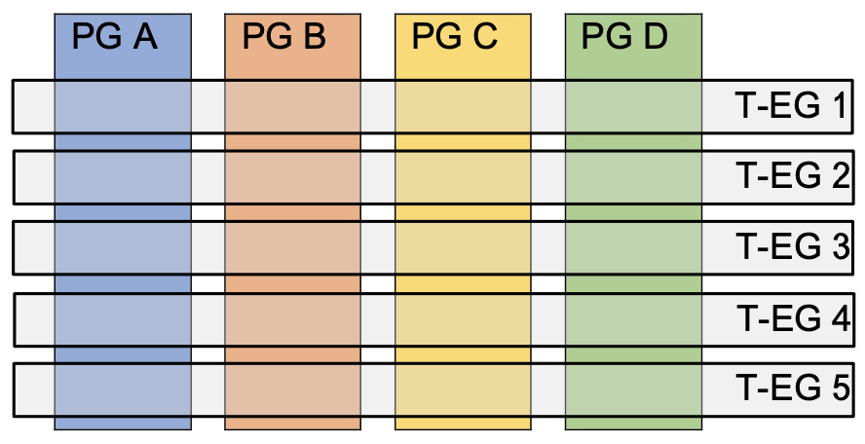
Constitution of project groups (PG) and theory expert groups (T-EG)
Distribution of key texts to expert groups for…
preparation of short presentations and handouts (between sessions)

focusing coherence:
Expert groups to be constituted transversally to projects groups, in order to have one expert of any of the theoretical core texts in every project group. This is supposed to enable a more solid linking of theoretical texts with the respective project texts in the final phase of the seminar. The handouts created in the expert groups as well as additional abstracts provided by the lecturers will be at hand as supportive information on the learning platform during this phase.

Plenary presentation of expert groups, discussion
Elaboration of a working definition of ‘memoria histórica’ within the project groups (between sessions)
Plenary presentation of working definitions, clarification of connections to theoretical texts, discussion and complementary observations — implications for the treatment of the topic in foreign language classes in secondary school, critical evaluation of the definition/location and contextualization of the concept of ‘memoria histórica’ in secondary education official reference paper (Bildungsplan Baden-Württemberg), ideas for deepening/enhancing the concept based on theoretical insights gained so far (subject science as first step; see second step below)

focusing coherence:
– unit supposed to show the relevance of scientific findings for the appropriate constitution of school topics
– narrowing down a topic for treatment in school requires previous grasp of its complexity (to avoid invalid didactical reduction and perpetuation of misconcepts)

Collaborative learning task (based on 4C/ID-Model): Recording of a short explanatory video on the concept of ‘memoria histórica’, to be used ad lib. as material in project dossiers (see original task below)

focusing coherence:
– theory-practice link by real-life-task: explaining as core practice in school education, transfer of theory-based content knowledge to a learner-oriented form, production of audiovisual learning material
– link to previous courses and between domains of professional knowledge: principles of good explanations are part of an obligatory introductory lecture in pedagogy in study year 1, materials then used are linked again to the current seminar platform as supportive information.
– evaluation of the videos by the lecturers as a means of measuring achieved coherence (knowledge integration)
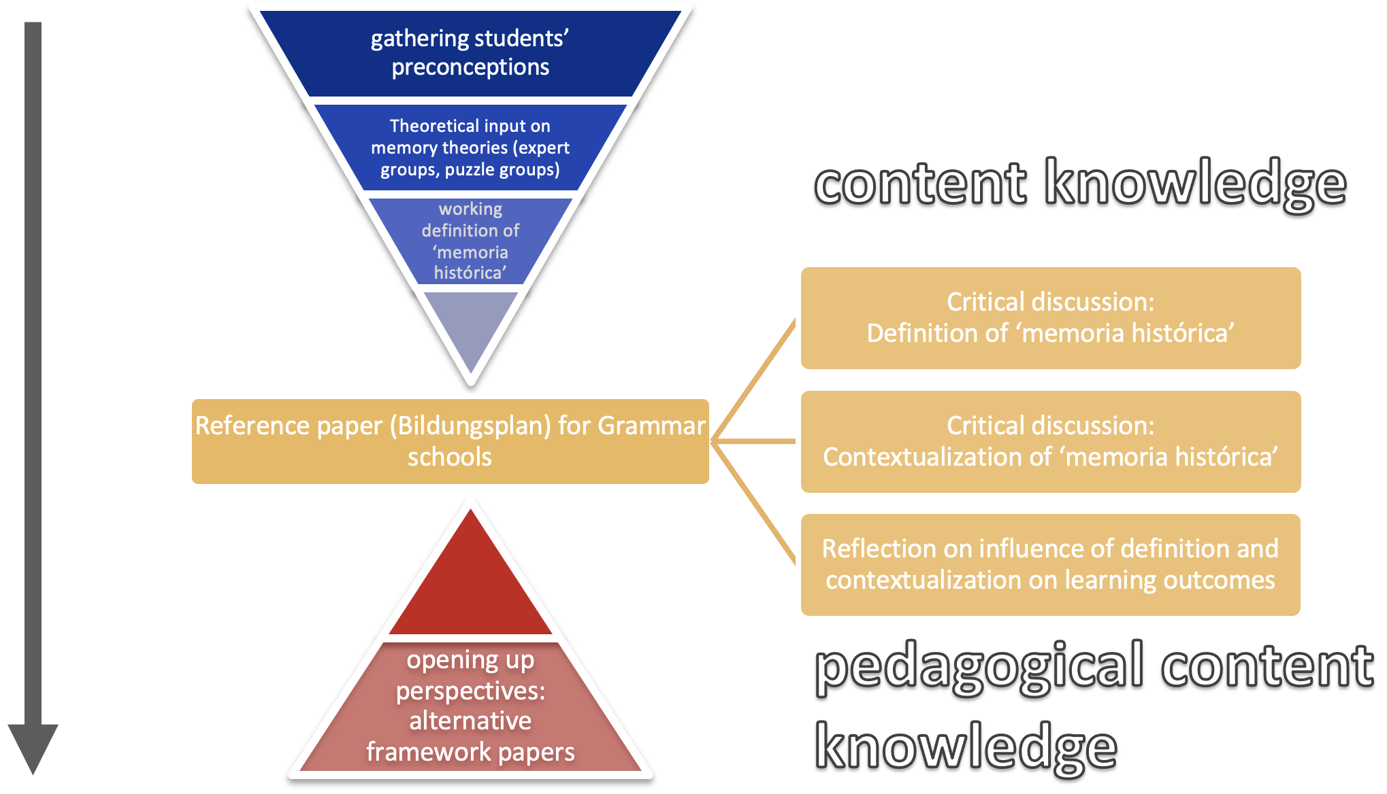
Step 2 progression: Narrowing down – opening up
Learning task: Defending the relevance of an understanding of cultures of remembrance for Spanish learners in secondary education, now taking into account alternative framework papers — second step in enhancing the concept from subject didactics perpective (see first step above)
Plenary discussion of created videos
Lecture on competence domains in secondary language education (functional, intercultural, symbolic, transversal etc.) — linkage to the topic of memoria histórica

Step 3: Reading literary texts in and for secondary foreign language class

Collaborative learning task: Criteria-based choice of text from the predefined corpus (see preliminary session) for project phase – supportive information: didactic research papers on selection criteria for literary texts in secondary education

Learning tasks: Cultural memory in literature, Literature as cultural memory: guided commentary on exemplary text excerpts, using provided supportive information on principles of structural text analysis (link to introductory lessons from first year of bachelor studies) and handouts on cultural memory theories elaborated by the participants (see step 2) — individual written feedback by tutor
(see original tasks below)
Plenary discussion of texts and students’ answers — adopting the learner’s perspective: reflection on difficulties of understanding the text — reflection on possible transfer in Spanish class
Discussing the transferability of the insights from the text analyses to the chosen project text
— last steps to be repeated several times with different text excerpts, progressively arranged according to their degree of complexity

focusing coherence:
– ‘vertical’ coherence to introductory courses from early study phases, reactivation of possibly unconnected and/or ‘fossilised’ content knowledge, retrospective demonstration of its practical relevance
– ‘vertical’ coherence to initial phase of this seminar (application of theories to texts)
– direct transfer on project text, immediate application of results from the study of exemplary texts to the project text als real-life task

Step 4: Project phase

Project groups work on the selected project text (see preliminary session) with a view to implementing it in real-life Spanish class in grammar schools – collaborative (rather than co-operative) creation of a dossier with supplementary materials
6 weeks of continuous project work supported by lecturers via bi-weekly face-to-face tuition units and online support

Guiding questions for elaboration of integrative dossier:
– Justify your choice of text excerpt(s) (according to formal-aesthetic, content-related and/or didactic criteria)
– Comment on the function of the text passage in the overall context of the novel
– Relate the text extract to the topic of memoria histórica and the relevant theories
– Make preliminary diagnostic considerations (prior knowledge – regarding language level, cultural/world knowledge, reading socialisation, pre-/misconceptions, difficulties)
– With what objectives would you implement your chosen text in class? (concrete graduated competence objectives, relevant paradigms in terms of psychology of learning, literary and cultural theory)
– What basic considerations for didactic-methodological design can you derive from the mentioned objectives? ('Analytical‘ vs. 'responsive' approaches, methods, sequencing)
– How could the chosen text be integrated into a superordinate task or unit on memoria histórica/cultures of memory?
– Which cross-phase and/or cross-curricular considerations seem relevant to you? (construction of conceptual cultural knowledge, language awareness, dealing with non-didacticised authentic texts)
– What cross-curricular approaches are also possible (> transversal competences...)?
– In your dossier, you should also collect other relevant memory media that you might use in addition... Justify your choice (functions, psychological, didactic and methodological aspects)

(adapted and revised) results of previous learning tasks
implementation in school

– by students themselves (induction phase)
– by in-service teachers via publication as OERs

additional supportive infromation (adapted to chosen text, needs of the group)
supportive information from past steps in seminar

focusing coherence: meaningfulness and theory-practice link through constant perspective on future use of the dossier under authentic conditions — possibility of implementation and feed-back by in-service teachers after publication

Step 5: Oral exam

30 min individual oral exam: Student explains and justifies the decisions made in the collaborative project dossier of his/her group

focusing coherence:
– Perspective of individual coherence-oriented final exam guarantees a minimum level of penetration of the entire dossier and different domains of knowledge (shared dossier –individual responsibility)
– ability to individually justify and evaluate existing material corresponds to the demands of professional life, where teachers have to make subject-scientific, didactic and pedagogic decisions primarily on an individual basis, even when working with third-party teaching materials (OERs, textbooks)
– Opportunity to discuss alternative solutions and ‘blind spots’
– Metareflection of the working mode in project group
– Assessment as a means of measuring achieved coherence (knowledge integration) by the lecturers (potentially showing need for adaptation of course design in subsequent cycles)

Overall design principles

The 4C/ID Model (4-Component Instructional Design Model) is an instructional design approach focusing on organizing and optimizing learning tasks and learning experiences for complex skill development. The model emphasizes four main components: Learning Tasks, Supportive Information, Procedural Information, and Part-task Practice. For details see the 4C/ID-Model project page). In terms of coherence in teacher education, the 4C/ID Model offers several benefits: (a) integration of theoretical knowledge and practical skills by using real-world learning tasks that require students to apply both; (b) scaffolding, as the model provides a structure for learning tasks that gradually increase in complexity, with appropriate support and guidance provided at each level; (c) active learning, as it engages learners in problem-solving, collaboration, and reflection; (d) focus on transferable skills.

Tandem teaching: Designed as a co-taught seminar with two lecturers from two different institutions and scientific domains, the seminar focuses on connecting subject-specific science (i.e. literary studies) and subject didactics. Both lecturers are present in each session, discussing topics from different perspectives (even though some sessions are predominantly led by one of the two instructors), showcasing divergent viewpoints and providing complementary insights. Consequently, both lecturers also jointly conduct the oral final exams. In terms of coherence in teacher education, this approach has several advantages:
(a) comprehensive understanding: Tandem teaching facilitates a more comprehensive understanding and fosters interdisciplinary thinking; (b) richer classroom discussions: Tandem teaching encourages more in-depth discussions, as it encourages students to evaluate different positions and develop their critical thinking; (c) co-teaching as real-life model: observing collaboration between instructors helps the students to recognise the value of teamwork and cooperation teaching; (d) improving the quality of teaching beyond the seminar: Tandem-teaching also allows the instructors to learn from each other, enhancing their understanding of their respective disciplines and of neighboring scientific domains, fostering a more comprehensive and interdisciplinary approach in other (non-co-taught) courses within the curriculum.

On the topic of successful collaborative teaching, see the tools and guidelines provided in the University of Zagreb's OER on ConnEcTEd project website, IO 5.

(back to top )

Exemplary memory medium to kick off the seminar

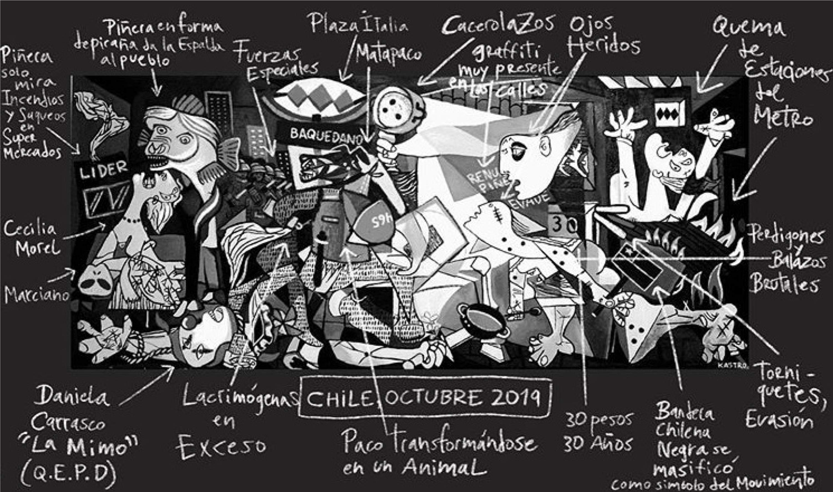
Graffiti (mural) “Chile/Octubre 2019, una reinterpretación del Guernica” by Miguel Ángel Kastro in memory of the social upheavals (estallido social) in Chile in 2019

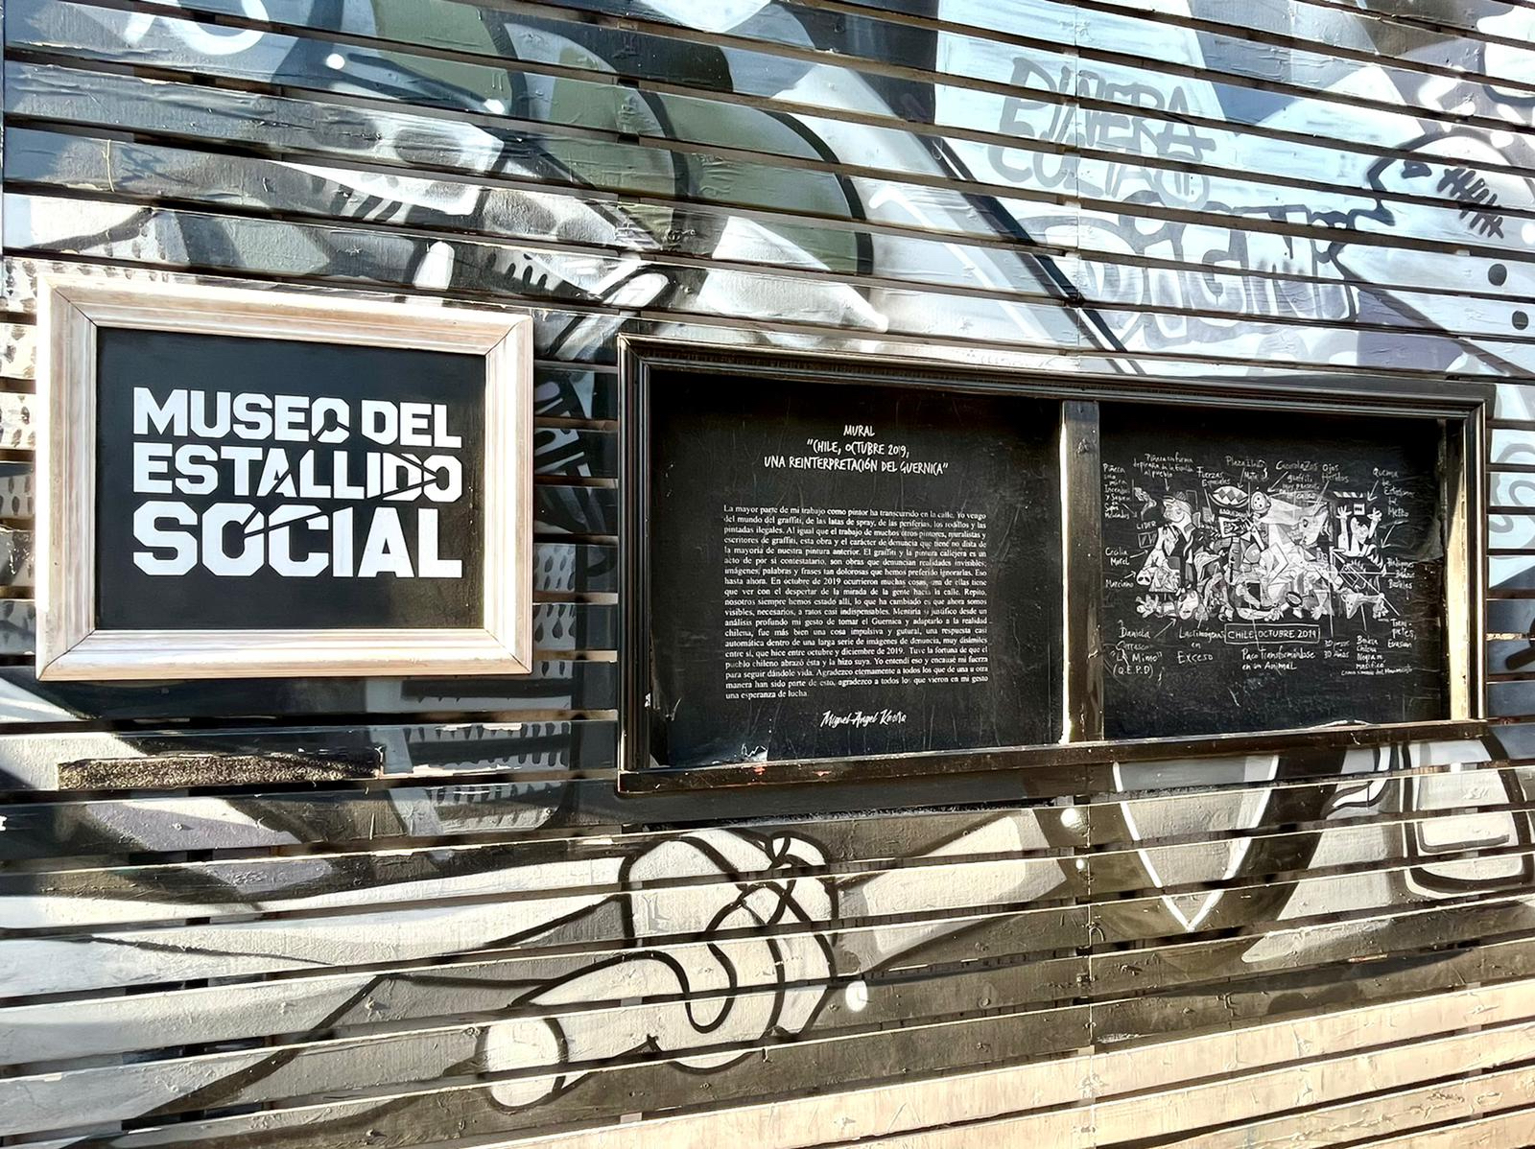
Reproduction of the graffiti in front of the museo del estallido social (https://museodelestallidosocial.org), Santiago de Chile

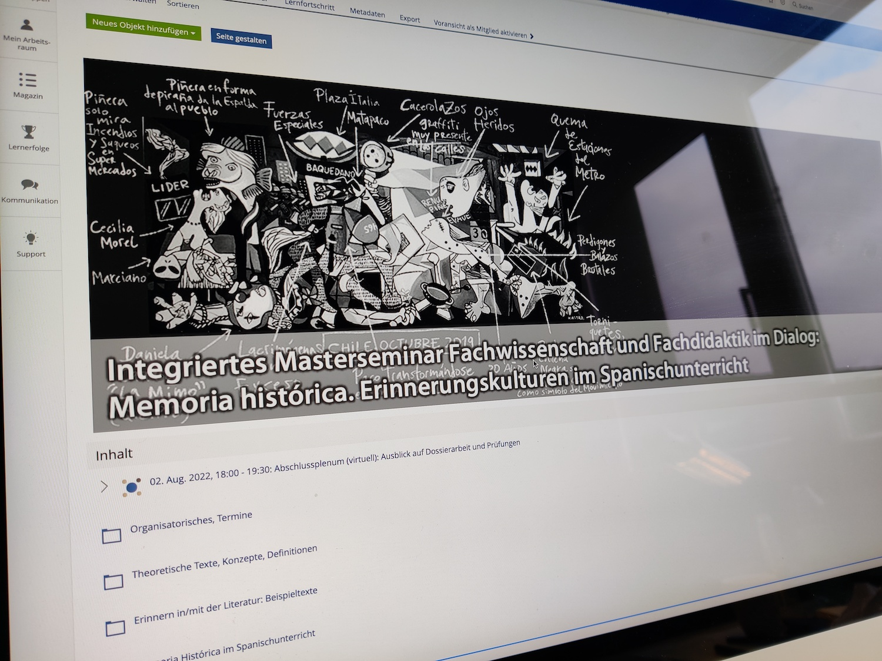
Mural in the header of the seminar’s learning platform space, serving as memory cue and reference point for learners throughout the semester
(back to top )
Integrative sample task: Explaining memoria histórica

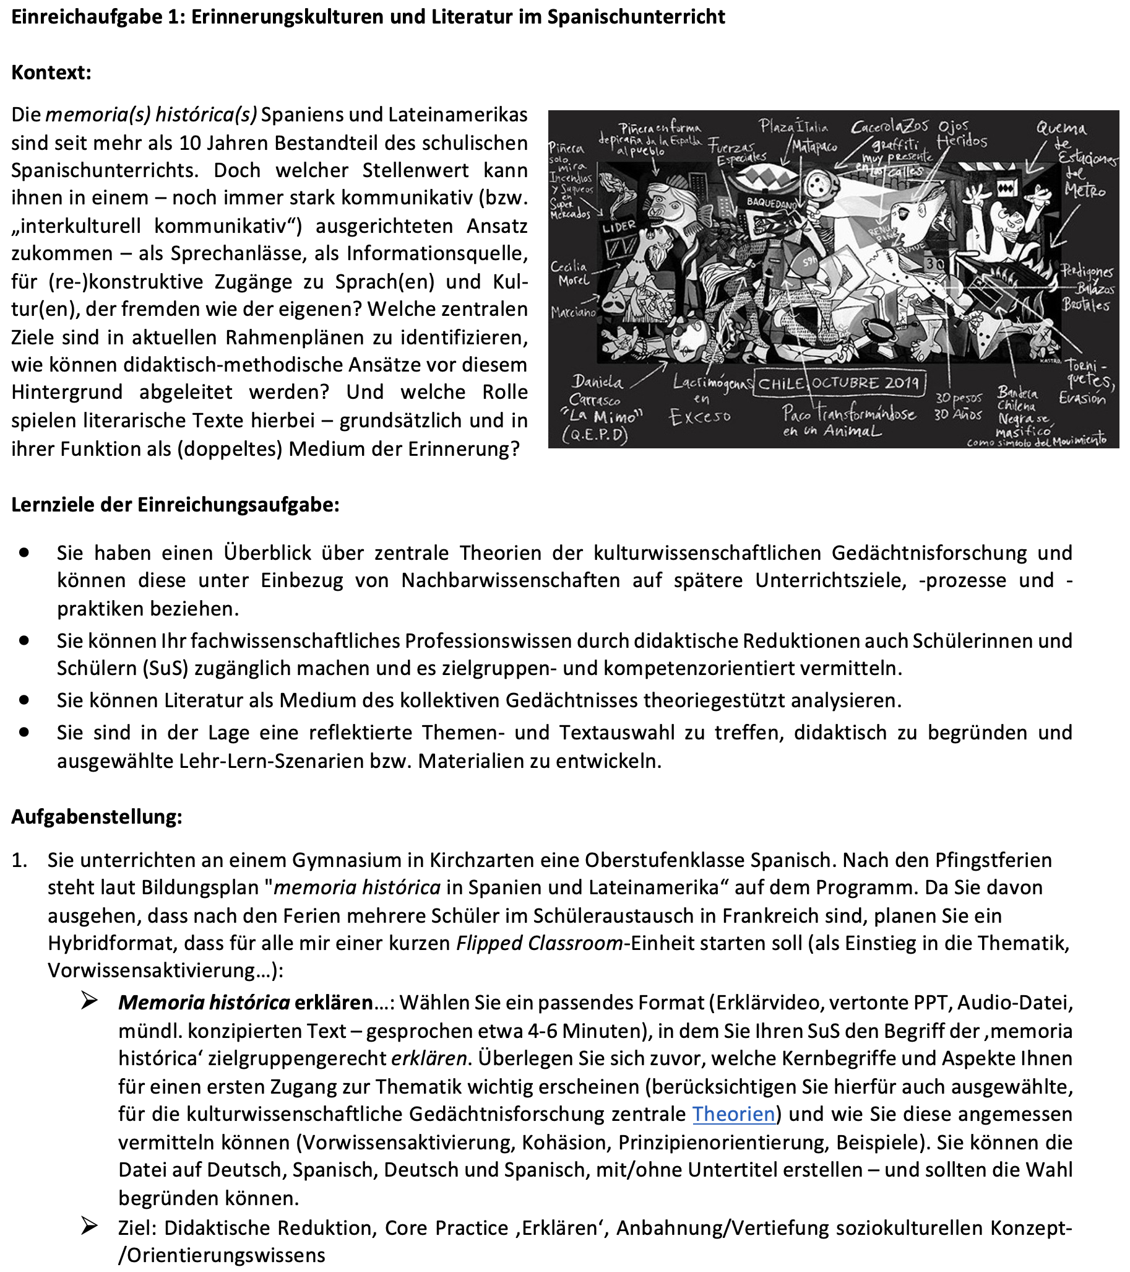
Translation of task description:

You are teaching a Spanish class at a secondary school in Kirchzarten. After the Pentecost holidays, the curriculum calls for “memoria histórica in Spain and Latin America.” Since you expect that several students will be on a student exchange in France after the holidays, you plan a hybrid format that should start with a short flipped classroom unit for everyone (as an introduction to the topic, activating prior knowledge, etc.):

Explain “memoria histórica”: Choose an appropriate format (explanatory video, PowerPoint with recorded audio commentary, audio file, transcribed oral text – with a duration of about 4-6 minutes) in which you explain the concept of “memoria histórica” to your students in a target-group-appropriate manner. First, consider which key terms and aspects seem important to you for an initial approach to the topic (also take into account selected theories central to cultural memory research) and how you can appropriately convey these (activating prior knowledge, cohesion, principle orientation, examples). You can create the file in German, Spanish, both German and Spanish, with/without subtitles – and you should be able to justify your choice.
Goals: Didactic reduction, core practice of “explaining,” introduction to/deepening of sociocultural concept/orientation knowledge.

(back to top )
Integrative sample tasks: Cultural memory in literature, Literature as cultural memory

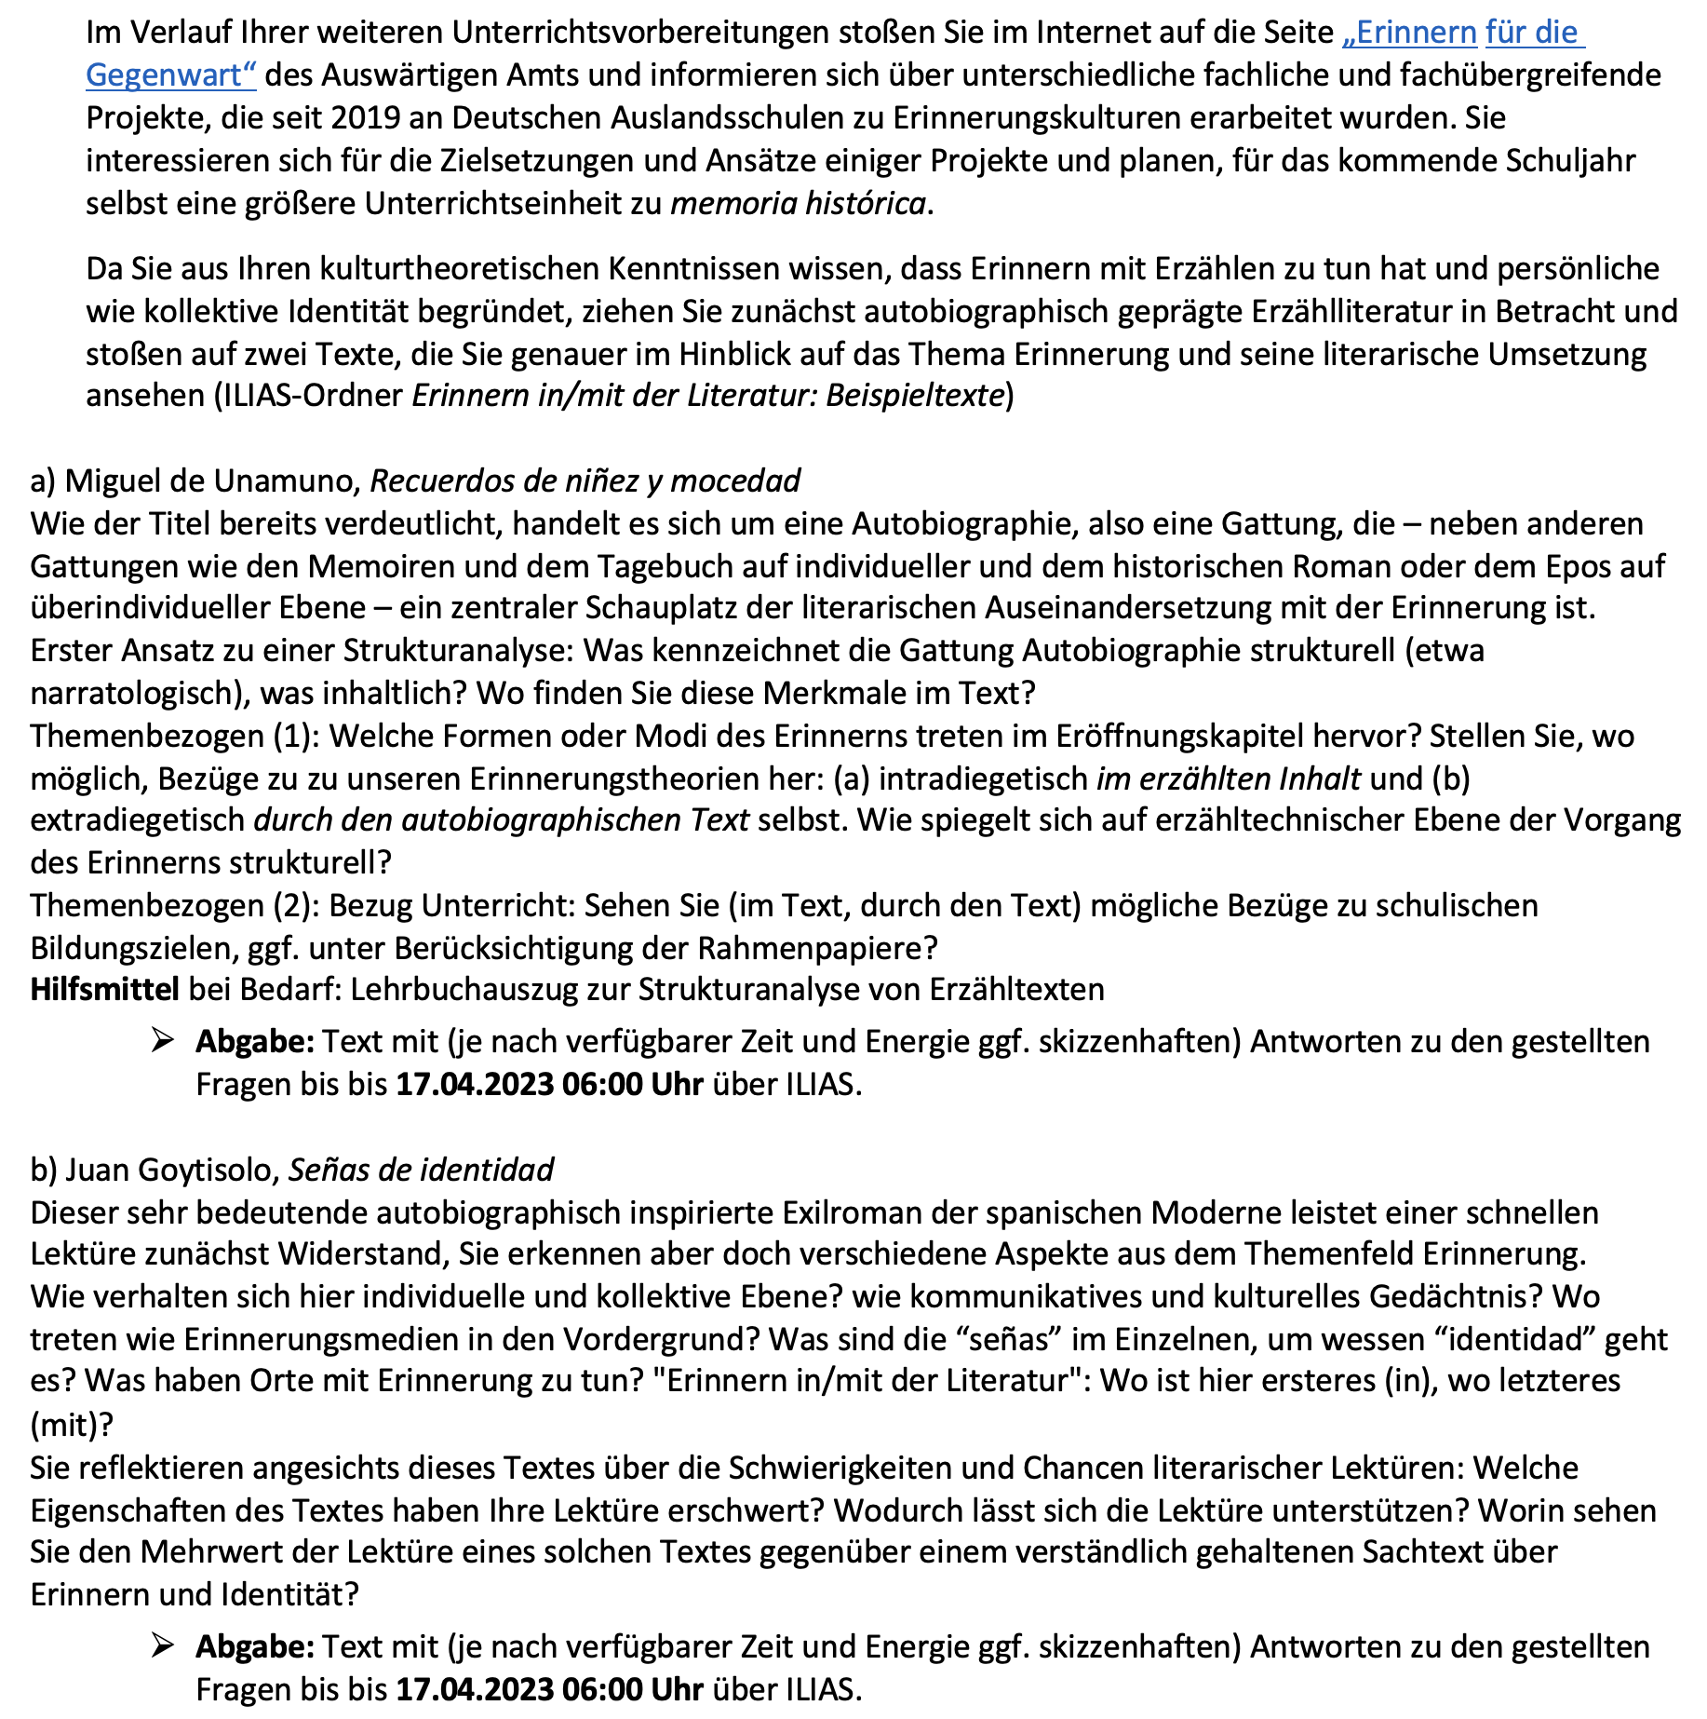
Translation of task description:
In the course of your further lesson preparations, you come across the website “Remembering for the Present” of the German Ministery of Foreign Affairs and inform yourself about various subject-specific and interdisciplinary projects on memory cultures that have been developed since 2019 at German schools abroad. You are interested in the objectives and approaches of some projects and plan to create a larger teaching unit on memoria histórica for the coming year.
Since you know cultural theories that show how remembering is related to storytelling and establishes personal and collective identity, you first consider autobiographically focused narrative literature and find two texts that you examine more closely in terms of memory and its literary implementation.

a) Miguel de Unamuno, Recuerdos de niñez y mocedad
As the title already makes clear, this is an autobiography, a genre that – alongside other genres such as memoirs and diaries on an individual level and historical novels or epics on a supra-individual level – is a central venue for the literary examination of memory.
First approach to a structural analysis: What characterizes the genre of autobiography structurally (e.g., narratologically), and what in terms of content? Where do you find these features in the text?
Theme-related approach (1): What forms or modes of remembering emerge in the opening chapter? Establish connections, where possible, to memory theories we discussed: (a) on the intradiegetic level, in the narrated content and (b) on the extradiegetic level, through the autobiographical text itself. How is the process of remembering structurally reflected on the narrative level?
Theme-related approach (2): Connection to teaching: Do you see (in the text, through the text) possible connections to educational goals, possibly taking into account the framework papers?

b) Juan Goytisolo, Señas de identidad
This very significant, autobiographically inspired exile novel of Spanish modernism at first sight resists a quick reading, but you still recognize various aspects from the field of memory.
How do individual and collective levels relate here? How do communicative and cultural memory relate? Where and how do memory media come to the fore? What are the “señas” (signs) in detail, and whose “identidad” (identity) is it about? What do places have to do with memory? “Remembering in/with literature”: Where is the former (in), where is the latter (with) playing a role?
Reflecting on this text, you consider the difficulties and opportunities of literary readings: What properties of the text have made your reading more difficult? How can reading be supported? What added value do you see in reading such a text compared to a comprehensible factual text about remembering and identity?
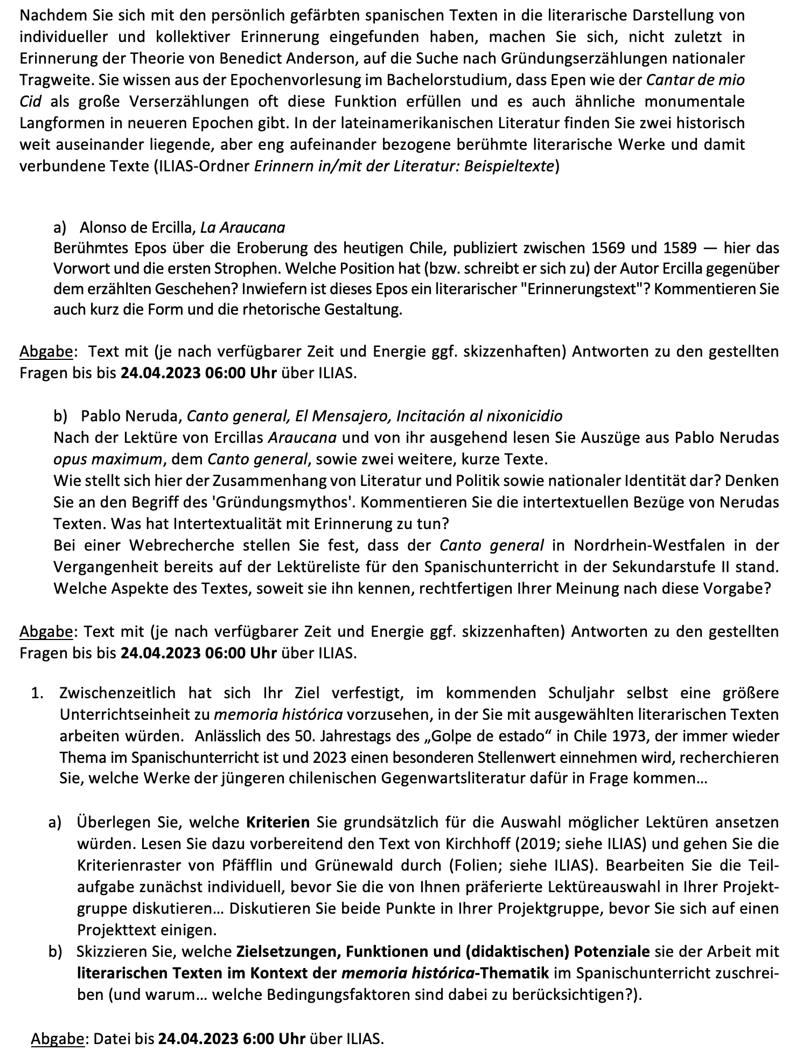
Translation of task description:
After familiarizing yourself with the autobiographically focused Spanish texts in the vein of literary representation of individual and collective memory, you now remember Benedict Anderson’s theory about collective memory as a key element in nationalism, you set out to search for founding narratives of national importance. You know from the survey on Spanish literary history in your bachelor’s degree that epics such as the Cantar de mio Cid often fulfill this function as grand narrative poems and that there are also similar monumental long forms in more recent epochs. In Latin American literature, you find two famous literary works and associated texts that are far apart in time but very closely related in content.

a) Alonso de Ercilla, La Araucana
Famous epic about the conquest of present-day Chile, published between 1569 and 1589 – see here the preface and the first stanzas. What position does the author Ercilla have in relation to the narrated events (or is he attributing to himself)? To what extent is this epic a literary “remembrance text”? Briefly comment on the form and rhetorical design.

b) Pablo Neruda, Canto general, El Mensajero, Incitación al nixonicidio
After reading Ercilla’s Araucana and taking it as a starting point, read excerpts from Pablo Neruda's opus maximum, the Canto general, as well as two other short texts.
How does the relationship between literature and politics and national identity appear here? Reflect upon the concept of the ‘founding myth’. Comment on the intertextual references of Neruda’s texts. What does intertextuality have to do with memory?
In a web search, you find that the Canto general already appeared on the reading list for upper secondary Spanish class in the state of North Rhine-Westphalia in the past. Which aspects of the text, as far as you know it, justify this in your opinion?

In the meantime, your plan has taken shape to create a larger teaching unit on memoria histórica in the coming year, in which you would work with selected literary texts. On the occasion of the 50th anniversary of the “Golpe de estado” in Chile in 1973, which is a recurring topic in Spanish lessons and will have a special significance in 2023, you research which works of younger contemporary Chilean literature are suitable for this purpose…

a) Consider what criteria you would generally apply for selecting possible readings. As preparation, read the text by Kirchhoff (2019; see ILIAS) and go through the criteria grids of Pfäfflin and Grünewald (slides; see ILIAS). First, work on the sub-task individually before discussing your preferred reading selection in your project group… Discuss both points in your project group before agreeing on a project text.
b) Outline what objectives, functions, and (didactic) potentials you would attribute to working with literary texts in the context of the memoria histórica theme in Spanish lessons (and why… which conditioning factors should be considered?).

focusing coherence:
– evaluation of the students’ submitted answers as a means of measuring achieved coherence (knowledge integration) by the lecturers: Are the school-related questions (also) answered with recourse to the results of the subject-specific analysis?

(back to top )

